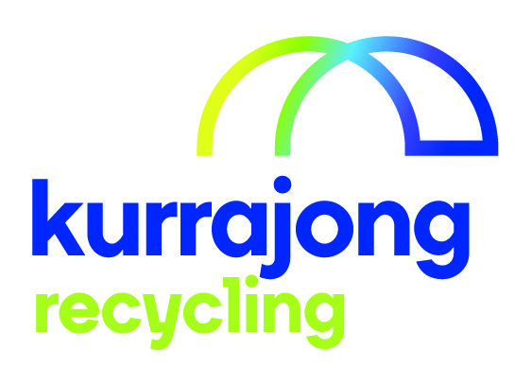

Factory Hand

Section / Service | Kurrajong Recycling
Location: | Wagga Wagga
Reporting to: | Supervisor of Area
Supervises (direct and indirect): | nil
Last reviewed: | October 2019

About Kurrajong - Kurrajong is a voluntary charitable organisation offering a broad range of services to babies, children, young people and adults with disabilities (aged 0-65) and their families. Kurrajong is registered as a provider of National Disability Insurance Scheme (NDIS) services and supports.

Our Vision - To create open, accessible and inclusive communities for all people.

Our Attributes – We care, we are community focused on the needs of people with disability and their families, our services are anchored in the communities we serve, we seek continuous improvement and excellence.
______________________________________________________________________________________________
Position Summary

This position requires a person to be motivated and willing to learn about recyclable materials, is able to work with others in a team, and is physically fit to carry out the required duties to enable Kurrajong Recyclers to provide an effective and efficient service to the community.

Position Key Responsibilities

It is expected that the Factory Hand will be responsible for the following:
- Know the materials which are recyclable:
- soft plastic bags and film - plastic lids No.4
- tin/aluminium cans - glass (brown, green, clear)
- PET bottles No.1 - newspaper
- milk bottles - cardboard
- coloured plastic bottles No.2 - highly coloured paper
- clear plastic bottles No.3 - white paper
- plastic bottles and tubs No.5 - bulky waste

- Remove rubbish from the recyclable material and place in the correct container/hopper/conveyer

- Work as a team member to complete tasks required:
- do the task that you are asked to do, so the team can complete their tasks
- help other team members when necessary to do a task, so the team can accomplish what is required

- Follow all health and safety requirements:
- listen to and follow supervisor’s instructions/directions
- wear the uniform and boots supplied by the service
- wear safety equipment when it is required, gloves, ear muffs or ear plugs and safety glasses
- follow Standard Operating Procedures (SOPs) to operate equipment. (No knowledge, No touch)
- know where the emergency stop buttons are and how and when to use them
- use appropriate lifting equipment and lifting methods

- Maintain a safe work area:
- tell your supervisor if anything could hurt yourself or others
- keep all walkways clear
- sweep areas when required
- walk only within the yellow lines
- report any accidents or incidents to your supervisor

- Participate in any training program/inservice or course which has been arranged

- Participate in his or her Employment Assistance Plan process and goal development every twelve months

- Assist in other duties that may be required to maintain operations

Please note: This list is indicative only and is subject to change. All Kurrajong staff are required to comply with any reasonable work requests as directed by the Manager of the area.

Signed

_____________________________________________________________________________________

Supported Employee’s Name Supported Employee’s Signature Date

