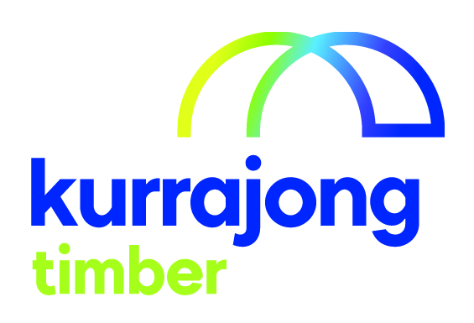

Factory Hand

Section / Service | Kurrajong Timber
Location: | Wagga Wagga
Reporting to: | Supervisor
Supervises (direct and indirect): | nil
Last reviewed: | November 2019

About Kurrajong - Kurrajong is a voluntary charitable organisation offering a broad range of services to babies, children, young people and adults with disabilities (aged 0-65) and their families. Kurrajong is registered as a provider of National Disability Insurance Scheme (NDIS) services and supports.

Our Vision - To create open, accessible and inclusive communities for all people.

Our Attributes – We care, we are community focused on the needs of people with disability and their families, our services are anchored in the communities we serve, we seek continuous improvement and excellence.
______________________________________________________________________________________________
Position Summary

This position requires a person to assist a machine operator, Senior Factory Hand and Supervisor. Tasks carried out by a Factory Hand may include stacking timber and painting survey peg material.

Position Key Responsibilities

It is expected that the Factory Hand will be responsible for the following:
- Follow all health and safety requirements:
- Listen and follow Supervisors instructions/ directions
- Wear the uniform and boots supplied by the service
- Wear the required safety equipment of ear muffs or ear plugs.
- Wear safety equipment when it is required, gloves, masks and safety glasses.

- Maintain a safe work area:
- Sweep areas as required or directed
- Tell the supervisor of things that could hurt yourself or other employees
- Report any incidents or near incidents to the supervisor.

- Work as a team member to complete the task required:
- Do the task you are asked to do so the team can complete their tasks
- Help other team members to do a task so that the team can accomplish what it is required.

- Participate in any training programs or courses

- Participate in his or her Employment Assistance Plan process and goal development every twelve months.

- Assist in other duties that may be required to maintain operations.

Please note: This list is indicative only and is subject to change. All Kurrajong staff are required to comply with any reasonable work requests as directed by the Manager of the area.

Signed

_____________________________________________________________________________________

Supported Employee’s Name Supported Employee’s Signature Date

