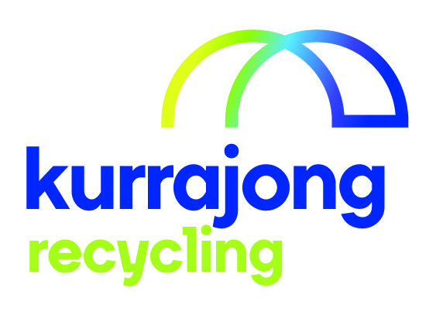

Computer Dismantler

Section / Service | Kurrajong Recycling
Location: | Wagga Wagga
Reporting to: | Supervisor of Area
Supervises (direct and indirect): | nil
Last reviewed: | October 2019

About Kurrajong - Kurrajong is a voluntary charitable organisation offering a broad range of services to babies, children, young people and adults with disabilities (aged 0-65) and their families. Kurrajong is registered as a provider of National Disability Insurance Scheme (NDIS) services and supports.

Our Vision - To create open, accessible and inclusive communities for all people.

Our Attributes – We care, we are community focused on the needs of people with disability and their families, our services are anchored in the communities we serve, we seek continuous improvement and excellence.
______________________________________________________________________________________________
Position Summary

This position requires a person to sort material into plastic, metals and rubbish and to dismantle Computer components.
Recognise reusable components and refurbish and/or maintain working units.

Position Key Responsibilities

It is expected that the Computer Dismantler will be responsible for the following:
- Follow all health and safety requirements:
- Listen and follow Supervisors instructions/ directions
- Wear appropriate clothing and boots supplied by the service
- Wear safety equipment of safety glasses when appropriate or requested by supervisor.
- Use appropriate lifting equipment and lifting methods.
- Use the correct tools to dismantle components
- Maintain a safe work area:
- Sweep areas as required or directed
- Tell the supervisor of things that could hurt yourself or other employees
- Report any accidents or near accidents to the supervisor.
- Use and maintain safety cut out switches when testing PC’s, Printers etc equipment
- Work as a team member to complete the task required:
- Do the task you are asked to do so the team can complete their tasks
- Help other team members to do a task so that the team can accomplish what it is required.
- Participate in any training programs or courses
- Participate in his or her Employee Appraisal process and goal development every twelve months.
- Assist in other duties that may be required to maintain operations.

Please note: This list is indicative only and is subject to change. All Kurrajong staff are required to comply with any reasonable work requests as directed by the Manager of the area.

Signed

_____________________________________________________________________________________

Supported Employee’s Name Supported Employee’s Signature Date

