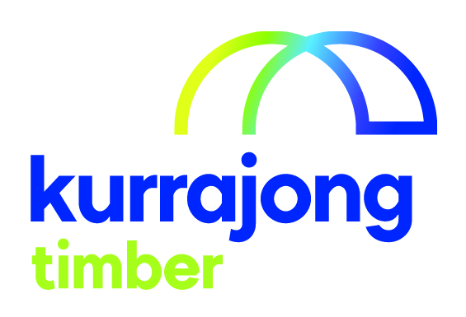

Assistant Supervisor

Section / Service | Kurrajong Timber
Location: | Wagga Wagga
Reporting to: | Supervisor
Supervises (direct and indirect): | nil
Last reviewed: | November 2019

About Kurrajong - Kurrajong is a voluntary charitable organisation offering a broad range of services to babies, children, young people and adults with disabilities (aged 0-65) and their families. Kurrajong is registered as a provider of National Disability Insurance Scheme (NDIS) services and supports.

Our Vision - To create open, accessible and inclusive communities for all people.

Our Attributes – We care, we are community focused on the needs of people with disability and their families, our services are anchored in the communities we serve, we seek continuous improvement and excellence.
______________________________________________________________________________________________
Position Summary

This position requires a person to be responsible to supervise a team on part of the production line. This position also requires a person to be competently assessed in all aspects of a Factory Hand and a Machine Operator.

Position Key Responsibilities

It is expected that the Assistant Supervisor will be responsible for the following:
- Act in a way in which other employees can see you as a responsible role model.
- Coach a team to follow procedures for a specific part of the production line.
- Assist in the delivery of instructing and supporting other employees on simple tasks.
- Follow supervisor’s direction.
- Ensure all health and safety requirements followed by self and team:
- Operate machinery following Standard Operating Procedures.
- Wear uniform and boots supplied by the service.
- Wear the required safety equipment of ear muffs or ear plugs.
- Wear safety equipment when it is required, gloves, masks and safety glasses.
- Know how to operate the safety switches to stop machines.
- Follow correct standard operating procedures for all equipment.

- Maintain a safe work area:

- Sweep areas as required or directed
- Tell the supervisor of things that could hurt yourself or other employees
- Report any accidents or near accidents to the supervisor.
- Work as a team member while instructing team to complete tasks required by:

- Assisting the team to do the task you ask them to do.
- Getting team members helping each other so that the team can accomplish what is required.

- Participate in any training programs or courses.
- Participate is his or her own Employee Appraisal process and goal development every 12 months
- Assist in other duties that may be required to maintain operations.

Please note: This list is indicative only and is subject to change. All Kurrajong staff are required to comply with any reasonable work requests as directed by the Manager of the area.

Signed

_____________________________________________________________________________________

Supported Employee’s Name Supported Employee’s Signature Date

