Pollution Incident Response Management Plan
54 Chaston Street Wagga Wagga
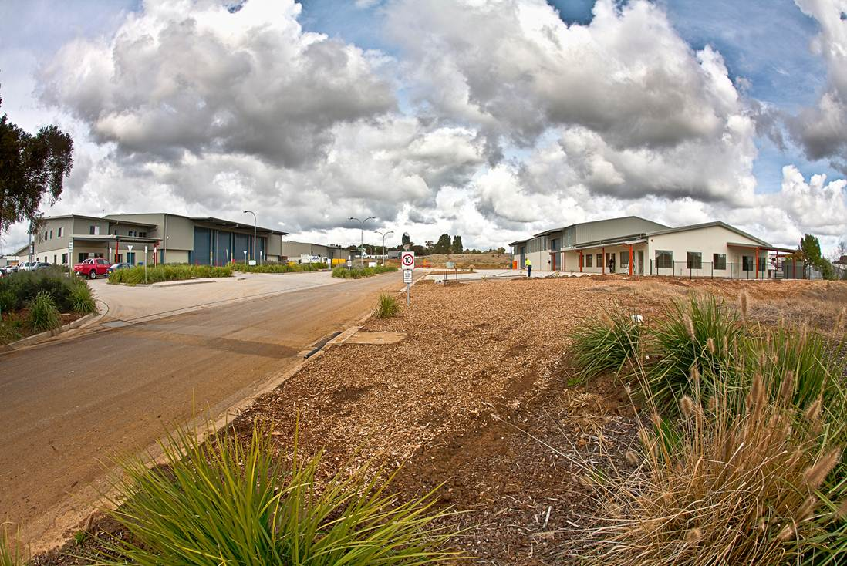
EPL number 20661
Our Vision: To create open, accessible and inclusive communities for all people.
PUBLIC VERSION
Contents
Section | Subject | POEO Act reference | Page/s
 | Contents |  | 2
 | Review History |  | 2
1 | Action Plan | Section 147 | 3-6
2 | Purpose and Objectives | Environmental Guidelines | 7
3 | Scope |  | 7
4 | Definition | Section 147 | 7
5 | Overview of Operations |  | 7
6 | Key Personnel | Clause 98C(g) and (h) | 8
7 | Description and Likelihood of Hazards | Clause 98C(1)(a) and (b) | 8
8 | Pre-emptive Actions Taken | Clause 98C(1)(c) | 8
9 | Inventory of Pollutants | Clause 98C(1)(d) and (e) | 9
10 | Safety Equipment and Systems | Clause 98C(1)(f) | 9
11 | Notification to Relevant Authorities | Clause 98C(g) and (h) and Section 148 | 9
12 | Communication with People | Clause 98C(1)(i) and (j) | 10
13 | Review of Incident and Response | Clause 98C(1)(l) | 10
14 | Staff Training | Clause 98C(1)(m) | 11
15 | Availability of this Document | Clause 98D | 11
16 | Testing of the Plan | Clauses 98C(1)(n)(o)(p); 98C(2)(f)(g); 98E(1) and 98E(2) | 11
17 | Site Map of Storm Water Drains | 98C(l) and (k) | 12
18 | Map of Flood Zone surrounding 54 Chaston Street Wagga | 98C(l) and (k) | 13
19 | Site Map of Pollutant and Safety Equipment Locations | 98C(l) and (k) | 14
Attachment 1 | EPA Licence |  | 15

Review History
25 September 2015 | PIRMP developed for site
25 September 2016 | PIRMP revised
18 August 2018 | Revision of procedures
3rd April 2019 | Review of PIRMP
3^{0th} January 2020 | Review of PIRMP, change of staff noted
21st April 2021 | Review of PIRMP, change of staff noted
6 September 2021 | Review of PIRMP
19 April 2022 | Review of PIRMP, change of staff noted
18 October 2022 | Review of PIRMP, change of staff and pollutants noted

1. ACTION PLAN
Actions to be taken during or immediately after a pollution incident.
If it is suspected that an incident may cause material environmental harm the Pollution Incident Response Management Plan will be activated. The plan is activated by contacting one of the six key people listed in the plan. This plan is based on six phases:
Phase 1. Assess
Phase 2. Stop and Contain
Phase 3. Notify
Phase 4. Communicate
Phase 5. Clean Up
Phase 6. Review

- Identify the severity, risks, and extent of the incident:
- What is the substance emitted?
- What are its properties?
- What is the volume of the emission?
- Is there a risk to health and safety of people on site, people off site or the environment?
- Do you have the necessary PPE to manage the emission?
- Are there any contributing factors that increase risk? eg. weather, increased population on or near site.

phase 1
ASSESS

- Stop the source of the emission.
- Ensure that necessary emergency materials are on hand to control and contain larger emissions:
eg.
shut down plant and equipment;
restore drums to upright position;
employ spill kit;
sandbag storm water outlets
secure loads;
close shed doors.

phase 2
STOP and CONTAIN

- Contact key people:
People responsible for activating and managing this plan:
Michael Merrylees – General Manager
Craig Salan - Manager
Tracy Bonet - Administration
Craig Lees – Senior Supervisor S/Shredding
Doug Brambley - Senior Supervisor CDS & E-Recycling
Steve Davis - Senior Supervisor MRF
People authorised to notify and coordinate relevant authorities:
Craig Salan - Manager
Ray Carroll - CEO
Michael Merrylees – General Manager
• Contact Relevant Authorities (promptly; in this order and if required):
If there is immediate threat to humans or property | 000
Wagga Wagga City Council | 02 6926 9100;
EPA | 131 555
Ministry of Health via the Public Health Unit Albury Office (After Hours ask for On Call Public Health Officer) | 02 0808100  A/H 02 6080890;
WorkCover Authority | 13 10 50
Fire and Rescue NSW | 000

phase 3
NOTIFY

- Notify people that may be affected by the incident and inform them of the actions they can take to minimise impact.
- On site: sound Evacuation Siren to activate Emergency Evacuation Procedure.
- Immediate neighbours: phone neighbouring businesses and doorknock neighbouring residents to inform of the risk and actions they should take eg. shut windows and doors, stay inside. Inform passing pedestrians and motorists if reasonably possible.
- Contact hospitals, nursing homes, schools and child care centres if needed.
- Supply chain – if operations are impacted:
JJ Richards
Cleanaway
JR Richards
Velolia
Smallmon Brothers Waste

phase 4
COMMUNICATE

- Clean up and take remedial action to restore the environment using SOPs.
eg.
pick up litter;
sweeping (manually and forklift broom);
activate coolfog system;
employ waste contractor to pump out stormwater basin
- Follow advice from authorities regarding specific clean up requirements.
- Disposal of pollutants in accordance with regulations.

phase 5
CLEAN UP

- Conduct an internal investigation, recording on form EMS 11.1 Incidence and Non-conformance Report. This report will be included on the next Management Review to be sent to the Board of Directors.

- Assist external investigation by EPA, Wagga Wagga City Council or any other investigators.

- Upon conclusion of review, communicate findings to people impacted by the incident:
On site – through meetings
Off site – by letter
- Test the effectiveness of this Pollution Incident Response Management Plan:
- at the first Emergency Evacuation Drill of each year (recorded in the red book);
- checked annually as part of the EMS internal review;
- one month after any incident to ensure controls are in place.
- Review the need of further training of staff.

phase 6
REVIEW

2. Purpose and Objectives
This Pollution Incident Response Management Plan (PIRMP) has been developed to satisfy obligations under the Protection of the Environment Operations Act 1997 (POEA Act) and associated Protection of the Environment Legislation Amendment Act 2011 (POELA Act) for licensed facilities.
This document is to be used in conjunction with other Kurrajong Waratah systems including the Environment Management System (ISO 14001:2015), Emergency Evacuation, Internal Audit and Crisis Management.
The objectives of this plan are to:
- Ensure comprehensive and timely communication about a pollution incident to staff at the premises, the Environment Protection Authority (EPA), other relevant authorities and community members who may be affected by the impacts of the pollution incident;
- Minimise and control the risk of a pollution incident at the facility by requiring identification of risk and the development of planned actions to minimise and manage those risks; and
- Ensure that the plan is properly implemented by trained staff, identifying people responsible for implementing it, and ensuring that the plan is regularly tested for accuracy, currency and suitability.
3. Scope
This PIRMP covers the site located at 54 Chaston St, Wagga Wagga.
4. Definition
Pollution incident means an incident or set of circumstances during or as a consequence of which there is or is likely to be a leak, spill or other escape or deposit of a substance, as a result of which pollution has occurred, is occurring or is likely to occur.
5. Overview of Operations
Kurrajong Recycling is operated by Kurrajong Waratah, a not for profit organisation providing services for people with a disability. It is managed by a Board of Directors with an executive team of Managers.
The finances of Kurrajong Waratah and Kurrajong Recycling are professionally managed to ensure that the cost of a pollution incident is covered by the appropriate level of insurance and contingency funds.
The operations of Kurrajong Recycling is managed by an Operations Manager and a team of senior supervisors.
6. Key Personnel
Any person on site has the responsibility of reporting a pollution incident to one of the following six key personnel who can then activate the Pollution Incident Response Plan:
Michael Merrylees – General Manager
Craig Salan - Manager
Tracy Bonet - Administration
Craig Lees – Senior Supervisor S/Shredding
Doug Brambley - Senior Supervisor CDS & E-Recycling
Steve Davis - Senior Supervisor MRF

7. Description and Likelihood of Hazards
The potential hazards of Kurrajong Recyclers’ Chaston Street Wagga Wagga site are:
Hazard | Risk | Contributing Factors
Dust generation | Low | Breakdown of dust suppression system
Uncontrolled release of litter | Moderate | Failure to follow procedures
Stormwater overflow | Low | Extremely high rainfall

8. Pre-emptive Actions Taken
Dust | Coolfog dust suppression system  Hard standing surfaces (concrete)
Litter | Maintenance program – cleanup daily x 3  Forklift broom  SOPs for securing loads etc.
Stormwater overflow | Retention basin to trap stormwater on site  Maintenance program to clean stormwater pit monthly  Control barriers to prevent litter entering stormwater system  Strainers fitted to drains, maintained regularly

9. Inventory of Pollutants
Pollutant | Maximum quantity
Fuel | 1900 litres
Oil | 600 litres
Waste water | 2000 litres

10. Safety Equipment and Systems
Equipment | Comments
SDS Register x 2 | Located in the workshop and the office.
Spill Kits | Located in the store, workshop and e-Recyclers.
Fire equipment | Marked on map. Fire Certificate updated annually. Equipment checked twice yearly.
Emergency Evacuation Drills | Conducted quarterly.
Personal Protection Equipment | Gloves, boots, glasses, dusk masks, hearing protection and hi-vis clothing. Issued to every person on site.
Bunds | Fuel and oil is bunded. Locations marked on map.
WHS Site Inspections | Conducted monthly by a trained WHS Rep.
Maintenance Inspections | Conducted daily by maintenance workers

11. Notification to Relevant Authorities
When a pollution incident has been identified and assessed, the following personnel are responsible for notifying and coordinating with relevant authorities promptly:
Craig Salan - Manager
Ray Carroll - CEO
Michael Merrylands – General Manager

External authorities to be notified (in order):
If there is immediate threat to humans or property | 000
Wagga Wagga City Council | 02 6926 9100
EPA | 131 555
Ministry of Health via the Public Health Unit Albury Office (After Hours ask for On Call Public Health Officer) | 02 0808100  A/H 02 6080890
WorkCover Authority | 13 10 50
Fire and Rescue NSW | 000

12. Communication with People
If it is determined that staff members and members of the public will be impacted by the pollution incident, the following protocols will occur:
- On site: sound Evacuation Siren to activate Emergency Evacuation Procedure.
- Immediate neighbours: phone neighbouring businesses and doorknock neighbouring residents to inform of the risk and actions they should take eg. shut windows and doors, stay inside.
- Inform passing pedestrians and motorists if reasonably possible.
- Contact hospitals, nursing homes, schools and child care centres if needed.
- Supply chain – if operations are impacted:

JJ Richards
Cleanaway
JR Richards
Veolia
Smallmon Brothers Waste

13. Review of Incident and Response

Once the pollution incident is remediated and operations are resumed, a review of the incident and the response to it will be conducted.

- Conduct an internal investigation, recording on form EMS 11.1 Incidence and Non-conformance Report. This report will be included on the next Management Review to be sent to the Board of Directors.

- Assist external investigation by EPA, Wagga Wagga City Council or any other investigators.

- Upon conclusion of review, communicate findings to people impacted by the incident:
On site – through meetings
Off site – by letter
- Test the effectiveness of this Pollution Incident Response Management Plan:
- at the first Emergency Evacuation Drill of each year (recorded in the red book);
- checked annually as part of the EMS internal review;
- one month after any incident to ensure controls are in place.
- Review the need of further training of staff.

14. Staff Training
- All staff undertake a training package, developed by Kurrajong Waratah, about the Kurrajong Waratah Environment Management System at induction and annually thereafter. Staff will be made aware of this Pollution Incident Response Management Plan (PIRMP) at the same time.
- Key personnel will undertake training about this PIRMP annually.
- Key personnel undertake chemical handling and spill response.
- All staff undertake safety training annually.
- Emergency Evacuation Drills are conducted quarterly.
- EMS and WHS issues are standard agenda items in every staff meeting.
- All visitors to the site must read and sign off on Form 13.2 Site Safety Plan annually.
- All staff training is recorded in a Training Register that is checked annually in the EMS internal audit system.

15. Availability of this Document

In accordance with Section 153D of the POEO Act, this full Pollution Incident Response Management Plan will be made available to all site personnel by displaying it on noticeboards in each section of the site.

In addition, the public will be able to view the public version of this plan on the Kurrajong Waratah website (contact details of key personnel will not be published in the public version). We will also provide the public version of the plan, without charge, to any person who requests it.

Kurrajong Waratah will ensure that a copy of the full plan will be onsite at all times, available to the EPA or other regulatory bodies if required.
16. Testing of the Plan
This plan will be tested annually at the first quarterly Emergency Evacuation Drill of each year. The test will include a desktop simulation as well as the practical exercise.
This will ensure that the information contained in the plan is accurate and up to date, and the plan is capable of being implemented in a workable and effective manner.
The plan will also be tested:
- 1 month after any pollution incident occurs;
- If there are significant changes to the hazards and risks on the site;
- If the plan is to be adapted to include other sites.

17. Site Map of Storm Water Drains
18. Map of Flood Zone surrounding 54 Chaston Street Wagga
19. Site Map of Pollutant and Safety Equipment Locations
Attachment 1
EPA LICENCE #20661

